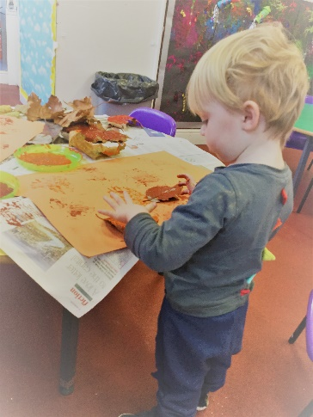
I have two daughters who spent time in Westgate Pre-school and they both remember that time as magical. The preschool is ideally equipped to welcome the children in a warm, friendly, yet professional setting where toddlers learn through play and have plenty of opportunities to develop emotionally, socially and intellectually.

Prospectus

“Comforting environment with very caring staff and exciting resources unite to provide a child centred setting” Ofsted

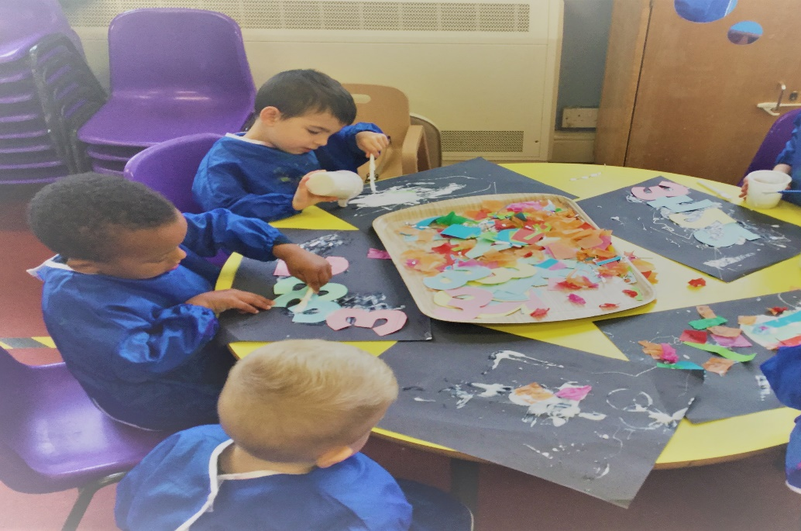

Welcome to Westgate Preschool Ltd

“Staff provide a delightful learning experience for all children, who make good progress in the pre-school” Ofsted

Westgate Pre-school is situated in the heart of the ancient town of Warwick. Located in a secure area of the Westgate Primary School site, adjacent to Westgate Children's Centre, it offers high quality day care for 23 children of 2 years to school age. A friendly atmosphere abounds and there is a strong sense of community.

How it all began…

The Pre-school was born out of the initiative of Pre-school supervisor, Ruth Ive, who has over 20 years’ experience in all aspects of early years development. Ruth was very aware of the need for high quality pre-schooling in Warwick and her vision was realized in the form of Westgate Pre-school, where she and her exceptional team of well-trained, experienced staff provide the very best early years provision in bright and airy characteristic surroundings. There is a lovely outdoor area with a climbing frame, playhouse, sand pit and water area. The children also use Westgate School’s playground when they take out cars, bicycles and other large outdoor play equipment.

Westgate Pre-school Ltd
Westgate Primary School,
Bowling Green Street, Warwick,
CV34 4DD
Tel 01926 494351
Email: westgatepreschool@btinternet.com

Registered charity No: 1064693

The Aims and Objectives of the Pre-School

“Good quality of teaching and effective use of resources”
“Children get tailored support to meet their individual needs on a daily basis” “Committed staff work well and have high expectations of all the children” Ofsted

- To encourage a relaxed, friendly atmosphere, where children can feel part of a ‘family’

- To work in partnership with the whole family, keeping parents involved and informed at all times

- To provide a stimulating, quality learning environment, using play as a medium for children to have fun whilst learning and exploring the world around them

- To treat children as individuals, encouraging them to value themselves and others, and to behave towards each other with courtesy, respect and consideration

- To support children’s social, emotional, physical, intellectual and cultural development, ensuring they feel that what they think and do are valued.

- To observe the progress of each child regularly and ensure each child’s learning needs are supported through activity planning

- To cover the seven areas of learning laid down in the Early Years Foundation Stage of the national curriculum, establishing a sound foundation for future learning and ensuring a smooth transition to Reception class at school.

The first 3 prime areas are normally developed first. These are:

Communication and language
Physical Development
Personal, social and emotional development

As children grow, the prime areas will help them to develop skills in 4 specific areas. These are:

Literacy
Mathematics
Understanding the world
Expressive arts and design

A Typical day

“Children are very well behaved” Ofsted

9.00am Welcome The children say hello, find their names and put them by their photos, put away their lunchboxes and coats and then choose from a variety of table top activities.

9.15am Register This is a chance to practice counting and number recognition. It is followed by a story or phonics activity recognising sounds and letters.

9.25am Activities Children choose or are called by their key worker for small group activities. There are always activities available that cover maths (sorting, counting, matching, sequencing, recognising numbers, comparing) writing and drawing (colouring, letter formation, news books, patterns), craft and imaginative play. There are also construction toys, a well-stocked book corner, a graphics table, computer with age-appropriate games, dressing up, sand, painting and the home corner, which changes to fit in with the topic.
We also have dancing and sport with specialist teachers, and once a week we use the hall for PE. We may also have visitors connected with our current topic.

10.45am Tidy up and snack time All the children help to tidy up and then gather on the carpet. This time is used to recall numbers and letters in songs, rhymes or games. Children wash their hands, find their name label and sit with their key worker who encourages them to share in a healthy snack and milk or water.

11.15am Activities Children choose activities. In fine weather children have free access to the outdoor area. We also take balls and hoops and cars/bikes into the school playground.

Throughout the day children are encouraged to develop confidence and self respect. They are encouraged and shown how to work independently, look after themselves, and also to take part in the life of the group, sharing and co-operating with others. They learn acceptable ways to express their feelings and to have respect for the feelings of others.

11.45am Tidy up time and recall The children are encouraged to talk about what has happened during the morning, and join in action rhymes and songs.

12.00pm Lunch (or Home time for children not staying for lunch.)
Children sit together with staff at tables to eat their lunch, and then play inside, or outside in good weather.

1.00pm Home time

The Learning Environment

“Children learn to treat others with respect and they play well together” Ofsted

Environment
At Westgate we aim to provide a happy, stimulating and caring environment, in which children can explore, enjoy and achieve through a wide range of child and adult initiated play activities.

There is a spacious main room with tables for group activities, a kitchen, large carpet area and off it, the cloakroom and recently refurbished children's toilets, and an adult toilet with nappy changing facilities.

Our recent outdoor area is situated in a sunny, secure corner of the school playground. It has artificial grass so the children will have access for more of the year, sand and water equipment, a playhouse with tables and chairs, cars and fire engines, mirrors and climbing frame with slide and fireman's pole. We have a range of plants, which the children help to look after, with child sized equipment.

We are also able to use the school facilities. The children sometimes take cars, trikes and other mobile toys onto the school playground, where there is lots of room for them to run around. We also use the school hall for dance style fitness and gym lessons.

Staff
We are proud of our well qualified, experienced staff and our high staff to children ratio, which ensures individual attention to needs and development of each child. Planning is based on the Early Years Foundation programme, and the team plan and review weekly to cater for every child's needs.

The permanent staff are:
Mrs Ruth Ive Pre-school Manager NNEB

Mrs Kim Clarke Pre-school Deputy Level 6 in Early Years

Mrs Lynsey Gascoigne Nursery practitioner /SENCO Level 3 in Early years

Miss Amy Dunne Training Assistant Working towards level 3

Mrs Anna Edgeworth Training Assistant

Mrs Anne Jones Admin support

Our membership of the Preschool Learning Alliance ensures we are constantly in touch with new thinking in the field of early year’s education and care. Training is regularly arranged through the Pre-school Learning Alliance, LA and local colleges.

Partnership with Parents

‘Strong partnerships with parents’’ Ofsted

Keeping in touch
Every child has a key worker who keeps a record of his or her progress and who will be able to answer any questions you may have. Staff are always available in the mornings or at the end of sessions to talk to parents. Should you wish to speak to Ruth she is always happy to arrange a convenient time.

Observations of the children, together with their progress summaries are recorded online. Parents therefore have the opportunity to add their own comments and post observations of their child’s achievements at home.

Key workers hold parents’ evenings each term to discuss progress, any concerns, and to set targets for the following term. In addition, parents of children who are about to move up to Reception will have a final meeting to discuss the information being transferred to school.

Committee
The Pre-school is now run as non-profit making company. However, we continue to have a fund-raising committee made up of parents and staff. As we are entirely self-supporting, fundraising is very important. All parents are more than welcome to join and help. Please contact a member of staff, if you are interested.

Some of the events (fundraising or just fun) can include:

Autumn term: carol singing, raffle, tombola at the Warwick Victorian evening, Christmas party, stall at Westgate School fayre

Spring term: sponsored walk, Easter egg hunt, ball, cake sale , Easter Fair

Summer term: sponsored bounce, Westgate School summer fete, outing, summer party

Safeguarding Children

“all staff have a good understanding of their responsibilities to protect children and to keep them safe within preschool” Ofsted

Westgate Preschool Ltd is committed to safeguarding and promoting the welfare of all children in our care.

Our named designated person is: Ruth Ive

Kim Clarke and Lynsey Gascoigne have also had in depth designated training.

All other staff have received Level 1 Child protection training.

We take necessary steps to safeguard and promote the welfare of children. We promote the good health of children, take necessary steps to prevent the spread of infection and take appropriate action if they are ill.

We manage children’s behaviour effectively and in a manner appropriately for their stage of development and particular individual needs.

We ensure that all adults looking after children or having unsupervised access to them are suitable to do so and hold a CRB or DBS certificate.

Conditions of placement and other information

Place Availability
Children can be accepted at the pre-school from 2 years old and may attend until they are required to attend primary school.
Please note that places for children under 3 years of age are only available if the ratio of staff to children is possible and therefore they cannot be guaranteed.

When a place becomes available, the form should be completed. Your place will be confirmed by preschool.

Session times
Monday to Friday 9:00 – 12.00 (8.30 Earlybirds start)
Lunch 12.00 – 1pm
Monday to Wednesday – 1.00 – 2.45pm

Parents/ carers have the option of school hot dinner at the current price of £2.66, or to provide a healthy balanced packed lunch, please include an ice-pack in the packed lunch.

Children are required to attend a minimum of 2 sessions a week to ensure the establishment of relationships and continuity of care.

Payment of fees

Pre-school will send out invoices half termly. These can be paid termly, half termly, monthly or weekly, but all fees are payable in advance and may be subject to change. They continue to be payable if the child is absent. (In cases of prolonged absence parents should consult the Pre-school manager about fee payment.) A minimum of one month’s notice is required for the withdrawal of a child from preschool; fees are still payable for the notice period unless otherwise agreed.

Complaints
If parents have any complaints about the allocation of places or any other issues they should be made to the Pre-school manager as soon as possible. Alternatively, complaints can be made in writing to the Company chairperson.

What to do now

If you are interested in place at Westgate Pre-School Ltd, please contact Ruth Ive to discuss available sessions.

Complete and return the Application form.

A welcome pack with a parent’s handbook containing information on policies, settling your child into preschool, etc, and permission forms will be sent to you before your child starts at the pre-school.

Current Fees

Current fees are £5.25 per hour. Children in receipt of government funding for ages 3 or 4 years are entitled to 15 hours free per week Monday to Friday.

2 year old fees are £5.25 per the hour until their third birthday.

First 15 hours free then pay £5.25 for any additional hours for 3 and 4 year olds and £5.25 for 2 year olds.

Session times 9:00 – 12:00
9:00 – 1:00
9:00 – 2.45

Early Bird sessions 8.30-9.00am are £2.75

The Government grant funds 15 hours per week which can be taken over several days. This grant is awarded the term after the child’s 2nd or 3rd birthday. We do ask that children stay still at least 12pm each day they attend as we still have to pay staff for the session.

Children on 3/4 year old funding (15 hours) will receive it automatically after parents fill in a declaration form in Pre-school.

For 2 year old funding, parents need to apply to : www.warwickshire.gov.uk/childcarecosts or call 01926 742218 for more information.

As we are open more than 15 hours per week, 3 and 4 year olds, whose parents are both working more than 16 hours a week are entitled to free funding for extended entitlement (30 hours). To apply for this, parents MUST go through the HMRC website: www.childcarechoices.gov.uk . Claims must be made in the term before you wish to access this funding.

Afternoon sessions £9.00 per session Monday, Tuesday and Wednesday (from April 2019)

Fees are reviewed annually in March.

Home Visits If you would like a member of staff to visit you and your child at home before they start to get to know you and tell you more about preschool, this can be arranged. Please speak to Ruth Ive.

Westgate Pre-School Privacy notice

Westgate Pre-School’s Privacy Notice

Westgate Pre-School
Bowling Green Street
Warwick
CV34 4DD
Phone: 01926 494351
Email: westgatepreschool@btinternet.com

Introduction
We are committed to ensuring that any personal data we hold about you and your child is protected in accordance with data protection laws and is used in line with your expectations.

This privacy notice explains what personal data we collect, why we collect it, how we use it and how we protect it.

What personal data do we collect?
We collect personal data about you and your child to provide care and learning that is tailored to meet your child’s individual needs. We also collect information in order to verify your eligibility for free childcare as applicable.

Personal details that we collect about your child include:
- your child’s name, date of birth, address, health and medical needs, development needs, and any special educational needs

Where applicable we will obtain child protection plans from social care and health care plans from health professionals.

We will also ask for information about who has parental responsibility for your child and any court orders pertaining to your child.

Personal details that we collect about you include:
- your name, home and work address, phone numbers, emergency contact details, family details and date of birth

This information will be collected from you directly in the registration form.

If you apply for up to 30 hours free childcare, we will also collect:
- your national insurance number or unique taxpayer reference (UTR), if you’re self-employed. We may also collect information regarding benefits and family credits that you are in receipt of.

Why we collect this information and the legal basis for handling your data
We use personal data about you and your child in order to provide childcare services and fulfil the contractual arrangement you have entered into. This includes using your data to:
- contact you in case of an emergency
- to support your child’s wellbeing and development
- to manage any special educational, health or medical needs of your child whilst at [my/our] setting
- to carry out regular assessment of your child’s progress and to identify any areas of concern
- to maintain contact with you about your child’s progress and respond to any questions you may have
- to process your claim for up to 30 hours free childcare (only where applicable)
- to keep you updated with information about our service

With your consent, we will also record your child’s activities for their individual learning record. This may include photographs and videos. You will have the opportunity to withdraw your consent at any time, for images taken by confirming so in writing. We use ‘Tapestry’ to record your child’s learning activities. Their data protection policies are available online.

We have a legal obligation to process safeguarding related data about your child should we have concerns about their welfare. We also have a legal obligation to transfer records and certain information about your child to the school that your child will be attending (see Transfer of Records policy).

Who we share your data with
In order for us to deliver childcare services we will also share your data as required with the following categories of recipients:
- Ofsted – during an inspection or following a complaint about our service
- banking services to process chip and pin and/or direct debit payments (as applicable)
- the Local Authority (where you claim up to 30 hours free childcare as applicable)
- the government’s eligibility checker (as above)
- our insurance underwriter (if applicable)
- our learning journal record system provider (Tapestry)
- the school that your child will be attending
- Outside agencies supporting your child

We will also share your data if:
- We are legally required to do so, for example, by law, by a court or the Charity Commission;
- to enforce or apply the terms and conditions of your contract with us;
- to protect your child and other children; for example by sharing information with social care or the police;
- it is necessary to protect our or others rights, property or safety
- We transfer the management of the setting, in which case we may disclose your personal data to the prospective buyer so they may continue the service in the same way.

We will never share your data with any other organisation to use for their own purposes

How do we protect your data?
We protect unauthorised access to your personal data and prevent it from being lost, accidentally destroyed, misused, or disclosed by:
- Using a password protected computer which is locked away after use.
- Paper data is stored in a locked cabinet.
- Photographs are deleted from setting cameras/iPods after use.

How long do we retain your data?
We retain your child’s personal data for up to 3 years after your child no longer uses our setting, or until our next Ofsted inspection after your child leaves our setting. Medication records and accident records are kept for longer according to legal requirements. Your child’s learning and development records are maintained by us and handed to you when your child leaves.

In some instances (child protection, or other support service referrals) we are obliged to keep your data for longer if it is necessary to comply with legal requirements (see our Children’s and Provider Records policies).

Your rights with respect to your data
You have the right to:
- request access, amend or correct your/your child’s personal data
- request that we delete or stop processing your/your child’s personal data, for example where the data is no longer necessary for the purposes of processing; and
- request that we transfer your, and your child’s personal data to another person

If you wish to exercise any of these rights at any time or if you have any questions, comments or concerns about this privacy notice, or how we handle your data please contact us. If you continue to have concerns about the way your data is handled and remain dissatisfied after raising your concern with [me/us], you have the right to complain to the Information Commissioner Office (ICO). The ICO can be contacted at Information Commissioner’s Office, Wycliffe House, Water Lane, Wilmslow, Cheshire, SK9 5AF or ico.org.uk/

Changes to this notice
We keep this notice under regular review. You will be notified of any changes where appropriate.

10.3 Application to join – Westgate Pre-School
Westgate Pre-School’s Application Form
Bowling Green Street, Warwick, CV34 4DD
Telephone: 01926 494351 Email: westgatepreschool@btinternet.com
Company Registration Number: 8800026

Personal details
First name(s) of child:
Surname of child: |  |  |  |  |  |  |  |  | Date of birth:
Full address:
 |  |  |  |  |  |  |  |  | Postcode:
Parent/carer name (1):
Relationship to child:
Full address (if different):
 |  |  |  |  |  |  |  |  | Postcode:
Daytime/work tel: |  |  |  |  |  |  | Home: |  |  | Mobile:
Parent/carer name (2):
Relationship to child:
Full address (if different):
 |  |  |  |  |  |  |  |  | Postcode:
Daytime/work tel: |  |  |  |  |  |  | Home: |  |  | Mobile:

Session request
Preferred start date:
Please tick the sessions you would like your child to attend:
Early Birds |  | □ Monday | □ Tuesday | □ Wednesday |  | □ Thursday |  | □ Friday
Morning |  | □ Monday | □ Tuesday | □ Wednesday |  | □ Thursday |  | □ Friday
Lunch |  | □ Monday | □ Tuesday | □ Wednesday |  | □ Thursday |  | □ Friday
Afternoon |  | □ Monday | □ Tuesday | □ Wednesday
This application places your child on our waiting list. We will contact you as soon as a suitable place becomes available. Please note that completion of this form does not guarantee a place for your child,
Once your child is offered a place and you accept it, on admission further personal information and family details are required for our records. Your child’s birth certificate is required at this point with a copy made for our file.
If you find that you no longer need the place, please inform us as soon as possible.
Should you decide you no longer need the place we will not retain the details on this application form (see our Privacy Notice).
Signed parent/carer (1): |  |  |  |  | Date:
Signed parent/carer (2): |  |  |  |  | Date:
Please be advised that this application form and offer of a place is subject to [our/my] terms and conditions provided to you. By signing this document, you acknowledge that you have read, understood and agree to these terms and conditions.

